**Experiment-2**

**Problem Statement-** Install a web server in VM in AWS.

**Step-1:** Go to EC2 dashboard and click on launch instances.

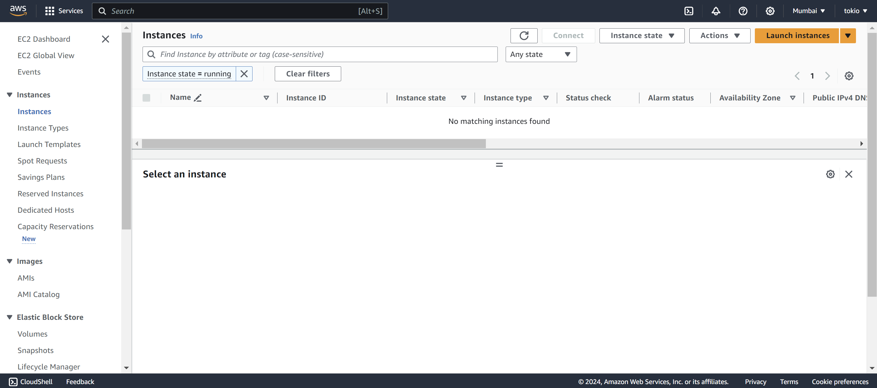

**Step-2:** Select the name of your instance and choose the linux AMI that you want to use.

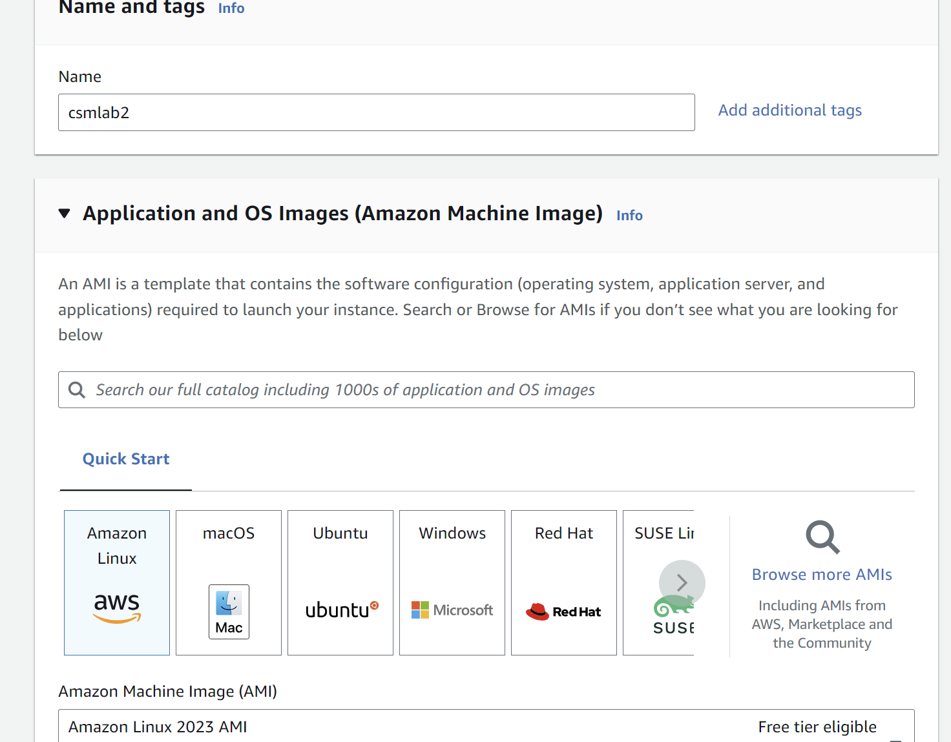

**Step-3:** Leave all the other details default and click on launch instance. After the instance is created, choose the instance and click on connect.

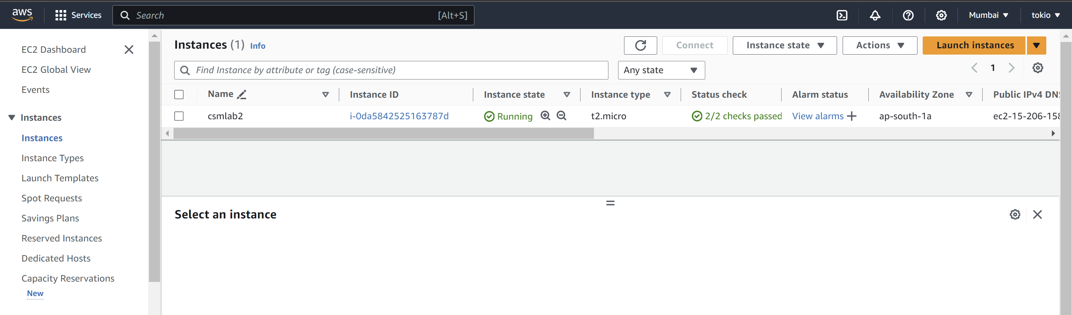

**Step-4:** Now connect to the EC2 linux instance using the EC2 instance connect.

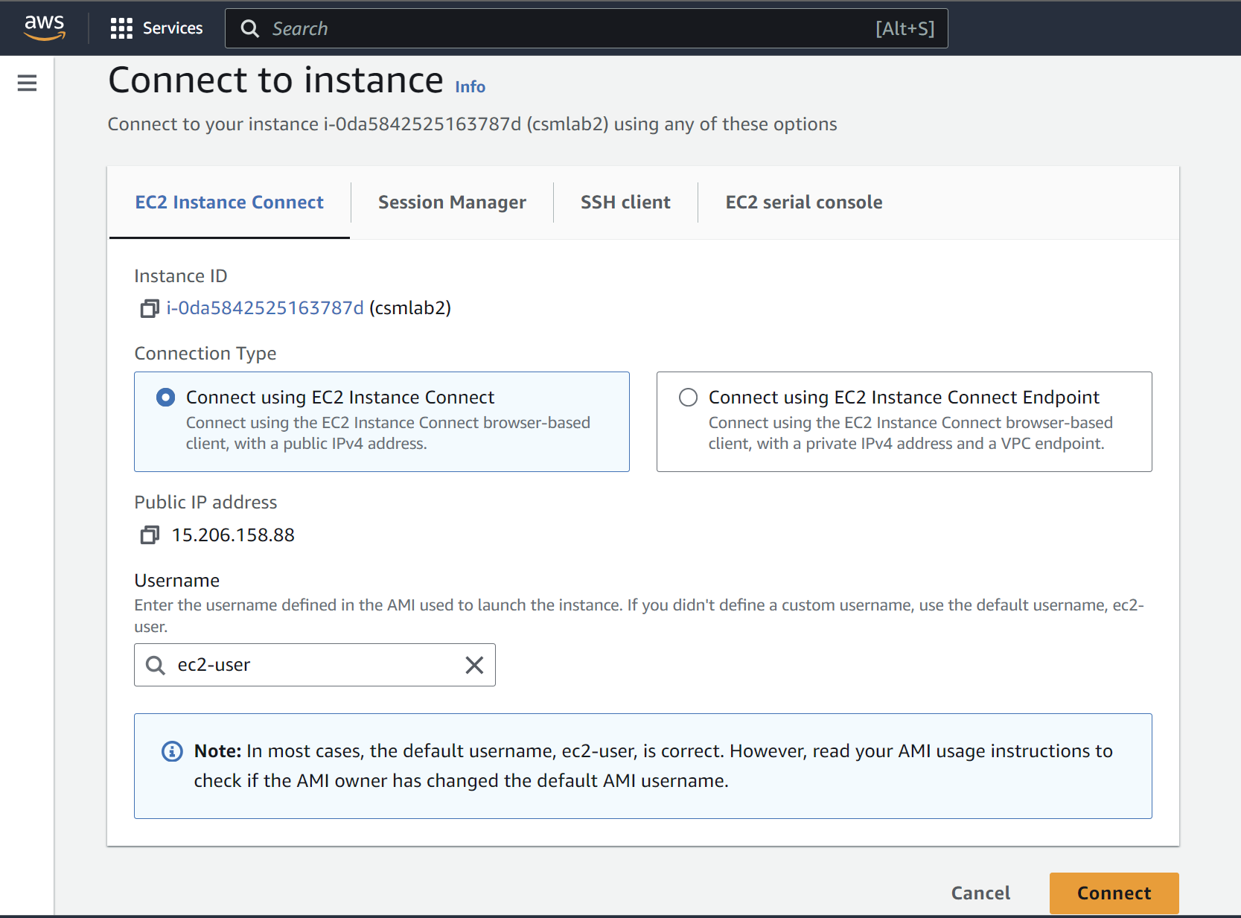

**Step-5:** Now firstly update your VM using the command:

sudo dnf update -y

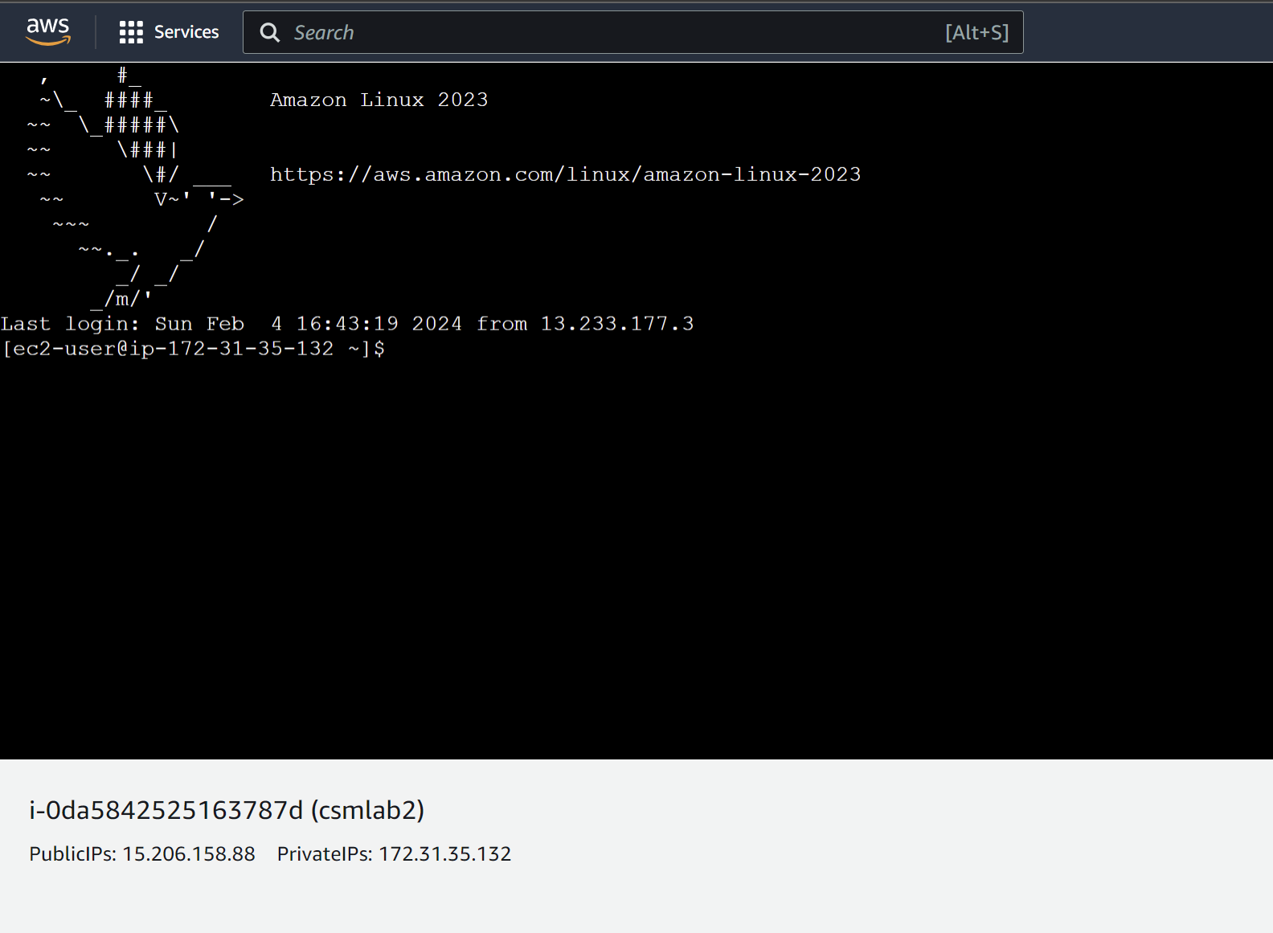

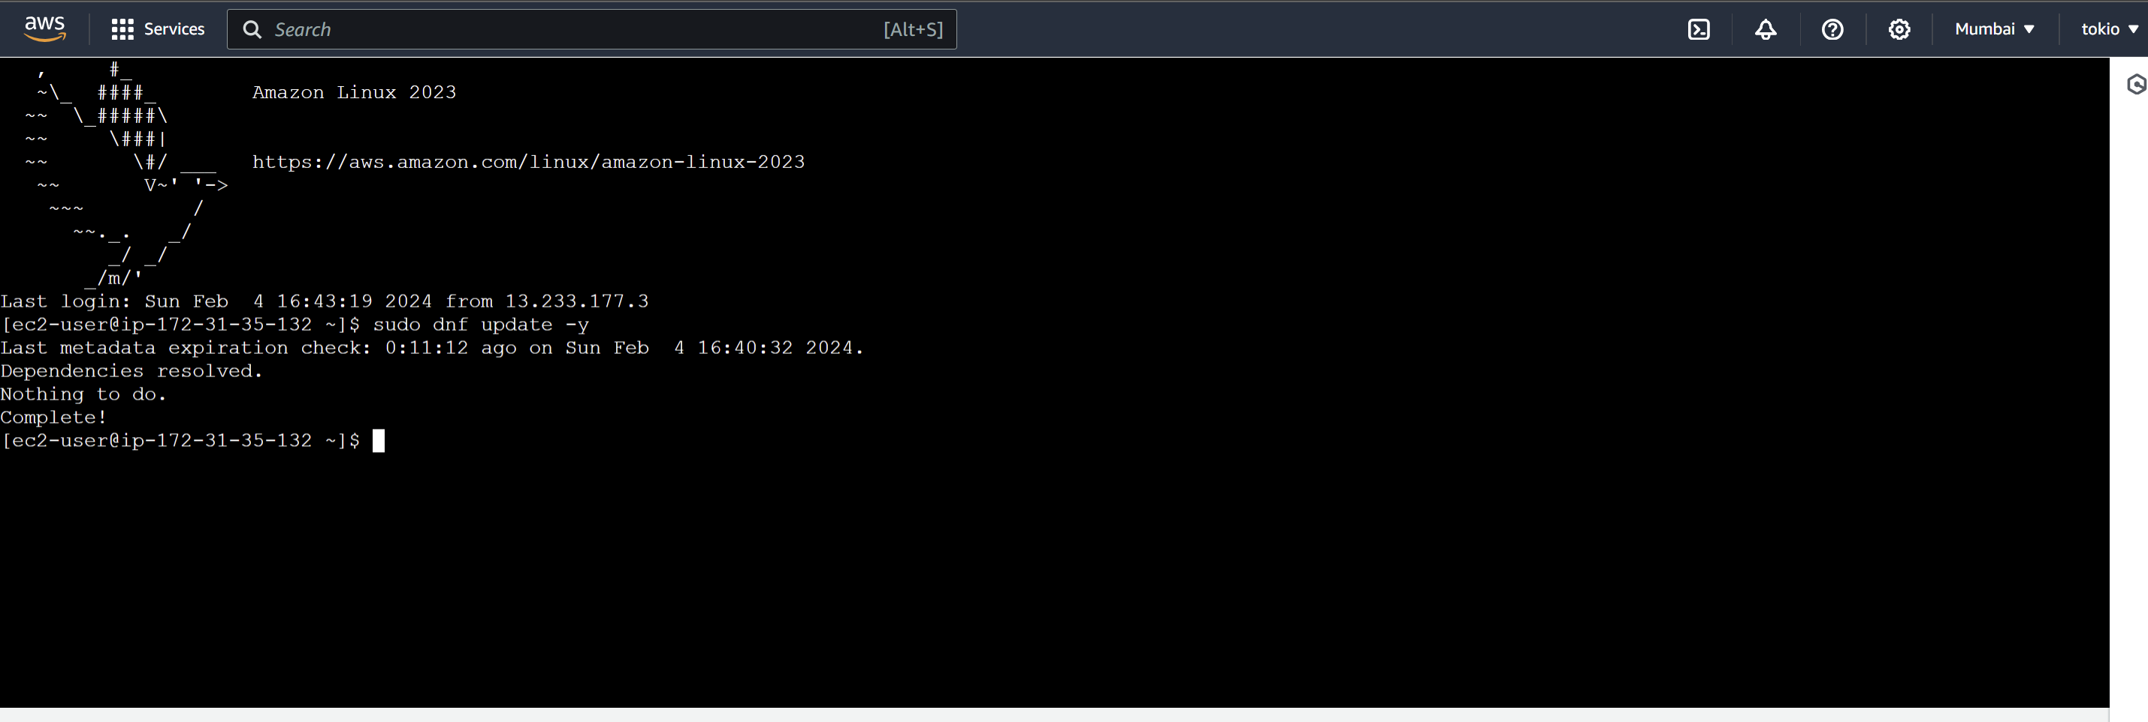

**Step-6:** Now install the latest versions of Apache web server using the following command.

sudo dnf install -y httpd wget php-fpm php-mysqli php-json php php-devel



**Step-7:** NowStart the Apache web server. Use the **systemctl** command to configure the Apache web server to start at each system boot.

sudo systemctl start httpd

sudo systemctl enable httpd

You can verify that **httpd** is on by running the following command:

sudo systemctl is-enabled httpd

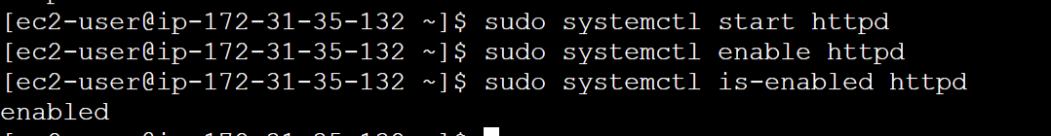

**Step-8:** Now test the web server. Go to the instance and copy the public IP of instance in the browser.

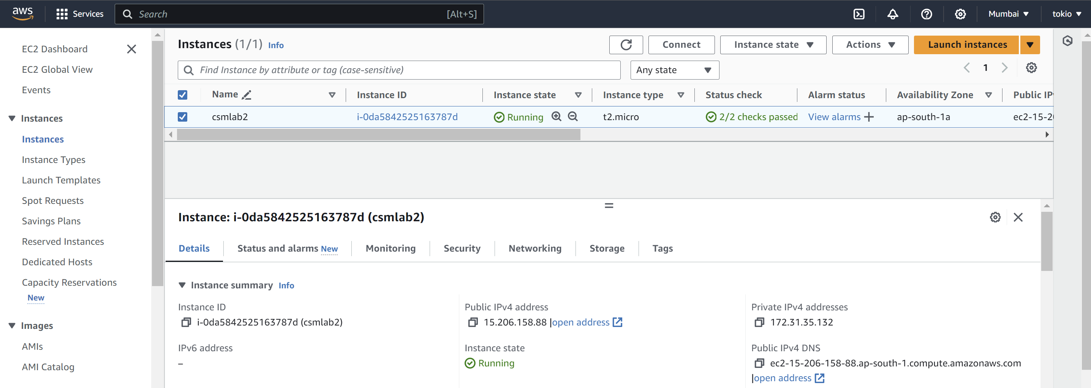

**Step-9:** The web server is accessible and working.

